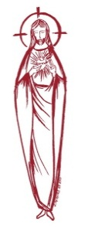
SACRED HEART PARISH

Sacred Heart Parish Founded 1814, The First Catholic Parish in the STate of New Jersey

Sacred Heart Church, 343 South broad Street, Trenton, New Jersey 08608

Holy Cross Church, 233 Adeline Street, Trenton, New Jersey 08611

ALL ARE WELCOME

Whatever your present status in the Catholic Church, whatever your current family or marital situation,

Whatever your past or present religious affiliation, whatever your personal history, age, background, or

race, whatever your own self-image or esteem, you are invited, welcomed, accepted, loved and

respected at the Parish of the Sacred Heart.

PASTOR

Rev. Msgr. Dennis A. Apoldite
frdennis@trentonsacredheart.org
PAROCHIAL VICAR
Rev. Charles Muorah
Rev. Marcin Kania, weekend Polish Mass
Felician Residence for Clergy
233 Adeline Street, Trenton, New Jersey 08611
609-393-4826 ext. 108 for Fr Charles
DEACONS
John Grussler and Dr. Christian Nnajiofor

Business Manager / ADMINISTRATIVE ASSISTANT
John DeSantis: secretary@trentonsacredheart.org
coordinator of religious education
Mary Tovar: reled@trentonsacredheart.org
COORDINATORS OF SACRED MUSIC
Natalie Megules ~ 609-575-6484
Rupert Peters ~ Gospel Mass 609-442-7871
MAINTENANCE DEPARTMENT
Frank Rios
Trustees
Jack Breuer and Ellieen Ancrum Ingbritsen,

OFFICE HOURS

9:00am – 4:00pm Monday – Friday

SACRED HEART PARISH OFFICE

343 South Broad Street, Trenton, NJ 08608

Phone: (609) 393-2801 ~ Fax: (609) 989-8997

WEB PAGE:

www.trentonsacredheart.org

CEMETERY RECORDS
Contact The Office of Catholic Cemeteries at 609-394-2017 or DirectorofCemeteries@DioceseofTrenton.org

SACRAMENTAL RECORDS
Sacred Heart Church, Saint John’s Church, Saint Francis Church, Saints Peter and Paul Church, Saint Stanislaus Church, Holy Cross Church, Blessed Sacrament Church, Our Lady of Divine Shepherd Church, Blessed Sacrament/Our Lady of Divine Shepherd Parish and Divine Mercy Parish.

Liturgy Schedule

Sacred Heart
Monday, Tuesday, Wednesday and Friday
12:10 Noon
Saturday Evening 5:15 PM
Sunday Morning 9:00 and 11:15 AM
HOLY CROSS
Monday, Thursday and Friday 8:00 AM
First Friday 6:30 PM Polish Mass
Saturday Evening 4:00 PM
Sunday Morning 10:00 AM Gospel
12:00 Noon Polish
For each Holy Day please reference the bulletin

SACRAMENTS
BAPTISM
Please call the Parish Office at least one month in advance.

RECONCILIATION

Every First Friday following the 12:10PM Mass SHC

Saturday afternoon ~ 4:30 to 5:00 PM SHC

Every Saturday from 3:30 to 3:50 PM HCC

Every Sunday 9:30 to 9:50AM HCC

and by appointment.
EUCHARISTIC ADORATION
First Saturday of the Month 2:30 to 3:30 pm
in Holy Cross Church
MARRIAGE
Please call the Parish Priest at least one year in advance to set up initial meeting and to confirm a wedding
date and time.
ANOINTING OF THE SICK
Please call the Priests any time 609-393-2801.
COMMUNION TO THE HOMEBOUND
Call the Parish Office to schedule home visit.
CONSIDERING PRIESTHOOD?
Email: Vocations@DioceseofTrenton.org

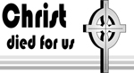
THE THIRD SUNDAY IN LENT
March 12, 2023

MASS INTENTIONS
Saturday, March 11
4:00 pm HCC~ Felicia J. Klama Stoj, and
Denice M. Stoj
5:15 pm SHC ~ Immaculatia Migliarese
Sunday, March 12
9:00 SHC ~ Holy Name Society
10:00 HCC ~ People of the Parish
11:15 SHC ~ Patricia Romanowsky
12:00 HCC Polish ~ Antionette Mydlowski
Monday, March 13
8:00 am HCC ~ F. Dajczak
12:10pm SHC ~ Msgr. Leonard Toomey
Tuesday, March 14
12:10 pm SHC ~ John Joseph Murphy
Wednesday, March 15
12:10 pm SHC ~ Special Intention
Thursday, March 16
8:00 am HCC ~ Joseph Pogorzelski
Friday, March 17
8:00 am HCC ~
12:10 pm SHC ~
Saturday, March 18
4:00 pm HCC~ Shelby Rowe
5:15 pm SHC ~ William Southwick
Msgr. Thaddeus Hogan – 105th Anniversary
Sunday, March 19
9:00 SHC ~ Daniel & Jean Ridorfino
10:00 HCC ~ People of the Parish
11:15 SHC ~ People of the Parish
12:00 HCC Polish ~ Dariusz Suszko

OUR SICK LIST
Chris Heulitt, Robert Leighton, Patrick Leighton, Alexander A. Ladnyk, Kelly Nitti, Deacon John Grussler, Lauren Clayton, Joseph Edralin, Margie Tiongson, Pat Tagliaferri, Kevin, Vincent Cooper, Jr., Gail Ladnyk, Leo Genovesi, Sloane Donnelly, Richard Buckley, Tony Ragolia, Wayne Herpel, Barbara Burrows, John Matthews, Pam Yuhas, Robert Mahon, Charles Burrows, Dorothy Amoroso, Maryann Sullivan, Regina Friedman, Rita Mich, Stanley Winowicz, Greg Schafer, Jack Hardiman, Paul Leighton, Amy Birk, Julia Grazioli, Matt and Leona Tydryszewski.

OUR DECEASED
Chris Brenner, Jenna Paulaski, Ethel Nowicki, and our friends at South Village, Riverside Nursing and Rehabilitation Center, Mill House and Waters Edge.

MINISTRY SCHEDULE
(subject to change)
Saturday, March 11
4:00pm HCC ~ Fr Charles L D Manger Em. M Herpel
5:15pm SHC ~ Msgr. Dennis L. L Seabrook EM. S&K Farruggio
Sunday, March 12
9:00 SHC ~ Msgr. Dennis L.R Paci Em A Green & W James
10:00 HCC ~ Fr. Charles L I Nwachukwu EM V Kamah
11:15 SHC ~ Msgr. Dennis L. J. Rhodes Em A. Woloff, N. Rhodes
12:30 HCC Polish ~ Fr. Marcin L. Gosia, Danusia

Saturday, March 18
4:00pm HCC ~ Fr Charles L. R Micharski Em. C Benitez
515pm Msgr. Dennis L. K. Willever EM. B DuMont & W Lewis
Sunday, March 19
9:00 Msgr. Dennis L. A Urbaniak Em H Mangan BJ Matthews
10:00 HCC ~ Fr. Charles L M Williams EM D Ezekua
11:15 SHC Msgr. Dennis L. M. Rhodes Em K. Myers, E. Wirzburger
12:30 HCC Polish ~ Fr. Marcin L. Anna, Gosia

WEEKLY COLLECTION
The collection for last weekend amounted to $12,611.00. Thank you for your continued support of our parish.

2023 ANNUAL CATHOLIC APPEAL UPDATE
Goal: $33,000.00
Pledged: $21,013.00 (64% of Goal)

READINGS FOR THE WEEK
Third Week of Lent
Sunday Ex 17:3-7; Rom 5:1-2, 5-8; Jn 4:5-42
Monday 2 Kgs 5:1-15ab; Lk 4:24-30
Tuesday Dn 3:25, 34-43; Mt 18:21-35
Wednesday Dt 4:1, 5-9; Mt 5:17-19
Thursday Jer 7:23-28; Lk 11:14-23
Friday Hos 14:2-10; Mk 12:28-34
Saturday Hos 6:1-6; Lk 18:9-14

PROMISE TO PROTECT
The Diocese of Trenton is committed to the norms of the U.S. Bishop’s Charter for the Protection of Children and Young People in regard to the reporting and investigation of sexual abuse allegations involving minors. If you have been sexually abused as a minor by anyone representing the Catholic Church, you can report it through the diocesan Hotline: 1-888-296-2965 or e-mail abuseline@dioceseoftrenton.org
Allegations are reported to the appropriate law enforcement agencies.

LAST YEAR’S ANNUAL CATHOLIC APPEAL
This past week, we received a rebate check from the Diocese of Trenton Annual Catholic Appeal Office for the 2022 calendar year. We received 15% of our goal of $33,000.00 and 50% of everything over our goal which amounted to $5,931.00. Thank you to all who participated and supported the appeal.

UPDATE ON THE 2023 APPEAL
We are extremely proud to announce that our parish has pledged 64% of our goal for this year, which amounts to $21,013.00. Thank you to all who made their pledge. With this kind of response we may be the first in the Diocese to attain our goal. If you have not made your pledge already, kindly consider participating in this year’s Catholic Appeal. Thank you for your support and generosity.
BOOK SALE
Kathleen Aviles, one of our long time members of the parish and author of children’s books, will be on the campus of Sacred Heart next weekend, March 19th to sign and sell three of her books, Including: Sidewalk Sally meets Recycle Buddy ($8.00) Droplets Ocean Dream ($11.00) and Mr. C. & Luz Fly Helicopter 9 ($14.00). She will be on the Holy Cross campus the following week. Why not treat your kids or grandkids to some healthy reading?

FEAST OF SAINT PATRICK ~ MARCH 17

Prayer to St. Patrick, Patron Saint of Ireland
St. Patrick, in your humility, you called yourself a sinner, but you became a most successful missionary and prompted countless pagans to follow the Savior.
Many of their descendants in turn
spread the Good News in numerous foreign lands. Through your powerful intercession with God, obtain the missionaries we need
to continue the work you began.
Amen.
FOOD COLLECTION NEXT WEEKEND
Please be generous with our needy neighbors.

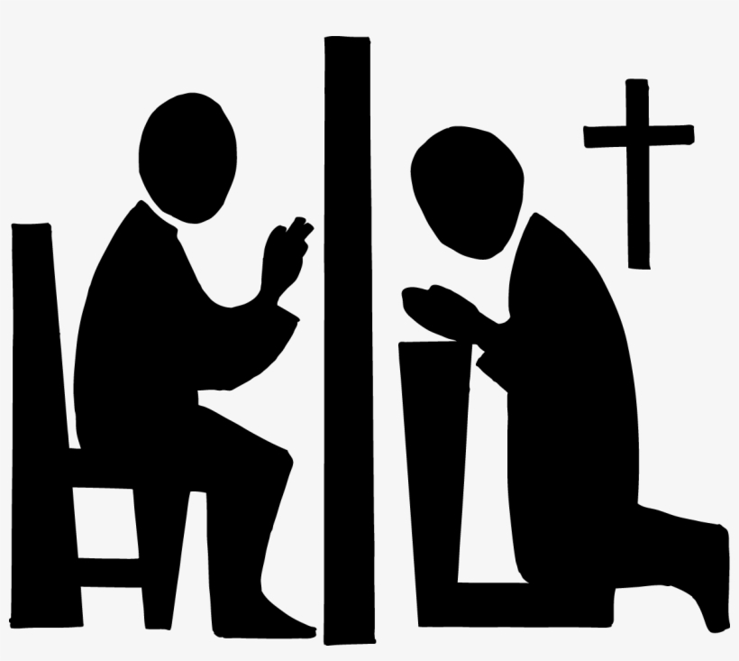

LENTEN PENANCE SERVICE
On Saturday Morning, March 18th at 10:00am our Annual Lenten Penance Service will take place in Sacred Heart Church. Please take this opportunity to be reconciled through this sacrament.

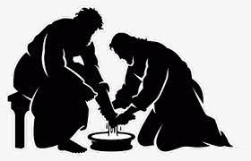
LENT
SACRAMENT OF RECONCILIATION
In addition the regular scheduled times for confession we have included: Holy Cross Church on Wednesday evening from 5:00 to 6:00pm and at Sacred Heart Church on Tuesday evening from 5:00 pm to 6:00 pm.

PARISH LENTEN DAY OF REFLECTION
On Saturday morning, April 1st, our Parish Lenten Day of Prayer and Reflection beginning at 9:00am and end at the completion of Mass which begins at 11:45 noon.

LENTEN PENANCE SERVICE
On Saturday Morning, March 18th at 10:00am our Annual Lenten Penance Service will take place in Sacred Heart Church.

STATIONS OF THE CROSS
The Stations of the Cross will be prayed every Friday at 12:00 noon at Holy Cross Church and every Sunday following the 9:00 Mass at Sacred Heart Church. Stations of the Cross will be prayed in Polish on Friday evenings at 6:30pm in Holy Cross Church.

LENTEN STATION CHURCHES
This Lenten pilgrimage takes us to Holy Ground throughout our county. Join us through this Lenten Pilgrimage of 2023.
Monday, March 13, St. John The Baptist
(7:00 PM) 1282 Yardville-Allentown Road, Allentown
Tuesday, March 14, St. Ann (7:00 PM)
1253 Lawrence Road, Lawrenceville,
Wednesday, March 15, Our Lady of Good Counsel (6:00 PM) ~ 137 W. Upper Ferry Road, West Trenton
Thursday, March 16, St. Joachim (7:00 PM)
19 Bayard Street, Trenton
Friday, March 17, St. Alphonsus (12:00 Noon)
54 East Prospect Street, Hopewell

.LENT SPIRITUALITY PROGRAM
Take Action Towards What You Care About
Topic: Jesus-ACTion
Making Space for Something New to
Happen in My Quest for Holiness
Presenter: Rev. Fr. Charles Muorah
Time: 10:15 – 11:30am
Venue: 1 Centre Street, Use back door off the church parking lot
Date: Fridays, March 3 – 31, 2023
Objectives include:
~To use acceptance, commitment and meditation healing tools to enhance or overcome obstacles
~Immersed in the divine presence to mindfully connect safely and meaningfully with God
~ Trusting in the divine protective presence and providence
~ Bonding with Jesus to develop more flexibility in accepting life experiences
~ To progressively understand where one needs to be more present in one’s life.

+ LENT 2023 +
The three traditional pillars of Lent are prayer, fasting and almsgiving. Through the three pillars of Lent we journey to develop a closer relationship to God. The 40 days of Lent should be filled with reflection, service and prayer.
ALL FRIDAYS ARE DAYS OF ABSTINENCE
From the age of 14, people are also obliged to ABSTAIN (no meat: this obligation prohibits the eating of meat, but not eggs, milk products or condiments of any kind, even though made from animal fat).The obligation to observe the laws of fast and abstinence is a serious one for Catholics. Failure to observe one penitential day in itself is not considered a serious sin. It is the failure to observe any penitential days at all, or a substantial number of penitential days, that must be considered serious.

DISPENSATION FROM ABSTINENCE ON
SAINT PATRICK’S DAY
Our Bishop is granting a dispensation from the obligation to abstain from eating meat to Catholics of the Diocese of Trenton on Friday, March 17. Those Catholics taking advantage of the dispensation, however, are asked to transfer the Friday abstinence obligation to another day of their choosing in Lent or to perform a work of charity (for example, a donation to the poor) or some exercise of piety (for example, a visit to Church and prayer before the Blessed Sacrament, a rosary, or some other prayer, etc.) to fulfill the spirit of the obligation.

EASTER BAZAAR & BAKE SALE

The Sisterhood at St. Josaphat's will hold its annual Easter Bazaar and Bake Sale on Friday, March 31, and Saturday, April 1, 2023.
Accepting orders through March 26. Call Daria 609-585-7863 or Slava 609-585-1294 or email Marta juzeniwmarta@gmail.com
*Pierogies $10/dz* Stuffed Cabbage $3*
*Easter Babka with or without raisins*
*small $4, medium $10, large $14*
*Poppyseed Roll* Fruit or Nut Roll $15*
*Other baked goods will be available for purchase.*
Pick up orders in lower hall of parish center
at 1199 Deutz Avenue Trenton, NJ 08611.
Thank you for your support!

